The United States Opioid Epidemic: Data and Visualizations

Team Members:

· *Lin Fu*

· *Rashmi Ray*

· *Rene Lizarraga*

· *Virendra Chauhan*

**Abstract**

Opioids are a group of drugs used for pain relief. Lower doses of Opioid can make the patient sleepy, whereas, the higher doses can slow down breathing and heart rate, that can prove to be fatal. When this medication travels through blood and reaches the opioid receptors in our brain cells, the cells release signals that manipulate the perception of pain and enhances the feelings of pleasure. A strong urge to continue this feeling of pleasure often leads to addiction of the drug.

Prescription Opioids are normally safe when taken as prescribed. The same prescription can be misused by an addict. More than 100 lives are estimated to be lost every day in the country due to Opioid overdose. This is a national crisis that is affecting the social and economic welfare of the nation.

The Centers for Disease Control and Prevention estimates that the total "economic burden" of prescription opioid misuse alone in the United States is $78.5 billion a year, including the costs of healthcare, lost productivity, addiction treatment, and criminal justice involvement.” (National Institute on Drug Abuse 2018)

Aware of the severity of the complication, our team decided to analyze the data collected by Center for Disease Control (CDC). We developed an application that provides the visual statistics of the Opioid epidemic across the country.

**Introduction**

According to the latest report publish in Mar 2018, by Nation Institute of Drug Abuse, more than 115 lives are lost every day nationally (National Institute on Drug Abuse 2018). In 1990s, this flood gate opened when around a one in every 3 American was estimated to suffering from chronic pain (Wikipedia n.d.). The drug companies took this opportunity to push the federal government to expand the use opioids for pain relief. The number of prescriptions nearly tripled from 76 million to 219 million in the period of just 20 years spanning from 1991 to 2011. (Wikipedia n.d.)

“Opioids are a diverse class of moderately strong [painkillers](https://en.wikipedia.org/wiki/Analgesic), including [oxycodone](https://en.wikipedia.org/wiki/Oxycodone) (commonly sold under the trade names [OxyContin](https://en.wikipedia.org/wiki/OxyContin) and [Percocet](https://en.wikipedia.org/wiki/Oxycodone/paracetamol)), [hydrocodone](https://en.wikipedia.org/wiki/Hydrocodone) ([Vicodin](https://en.wikipedia.org/wiki/Hydrocodone/paracetamol), [Norco](https://en.wikipedia.org/wiki/Hydrocodone/paracetamol)), and a very strong painkiller, [fentanyl](https://en.wikipedia.org/wiki/Fentanyl), which is synthesized to resemble other [opiates](https://en.wikipedia.org/wiki/Opiate) such as [opium](https://en.wikipedia.org/wiki/Opium)-derived [morphine](https://en.wikipedia.org/wiki/Morphine) and [heroin](https://en.wikipedia.org/wiki/Heroin)” (Wikipedia n.d.)

The US health care system has been playing an invisible yet absolutely avoidable role in causing this outbreak. According to an article publish Oct 2017, Professor Judith Feinberg from the West Virginia University School of Medicine stated "Most insurance, especially for poor people, won't pay for anything but a pill." (Amos 2017) He continued on to explain that even if a better solution is available, the insurance companies either mostly don’t cover it or it involves lot of paperwork for preapproval process, thus the patients resort to the prescription pain killers that in most cases leads to addictions. A study published 2018 has found that 75% of opioid users were introduced to the drug though a legitimate prescription (Wikipedia n.d.)

**Data Sourcing**

Two data sources were used for this analysis focusing on opioid use as a prescription medication and its impact from 2010 to 2016.

In the United States, the Center for Disease Control and Prevention (CDC) is the leading public health institute that not only protects public health, it also conducts in depth research to facilitate solutions for better control of diseases and epidemics. The organization has a major data collection system in place to support its research and analysis the national trend. The team has used the drug overdose data that is available publicly from the organization’s website. This dataset is used primarily analyze drug overdose deaths, opioid overdose deaths and opioid prescriptions (CDC n.d.). The dataset is available in the project team’s GitHub repo (GitHub n.d.).

The second dataset used is selected from

Kaiser Family Foundation’s [KFF] website. KFF is a US based non-profit organization that focuses on major health care issues. The organization claims itself a highly credible source of healthcare data (Wikipedia n.d.). The team has sourced the dataset from KFF to analysis the opioid related deaths across 50 states, gender, races from 2010 to 2016. This dataset is also available in the team’s git repository (Github n.d.).

**Tidy Data and Data Cleaning**

The data were handled using the tidy data principles (Wickman 2014). Each variable forms a column. Each observation forms a row. Each type of observations data forms a table.

First, prescription data by state contained observations without prescriptions counts. Upon researching further, we identified that the missing values were a safeguard measure by the federal agencies to protect the identity of sparsely populated geographies. These observations were ignored in our analysis.

Second, because the two datasets utilized in our research are sourced from different organizations, we had to normalize the State names to relate the sources to each other. For example, one source had a state value of ‘Alabama’ and the other source value was ‘AL’. We created a dictionary to relate the two values for all 50 states and Washington D.C.

We then used the merge function to create an accurate data representation of the combined data sets by state and year.

With these steps is place, we were able to continue with our analysis.

**Statistical Analysis**

In order to derive the relationship between Opioid prescriptions and Opioid death, the variables were plotted in a scatter plot and derived an r2 of 0.79. The linear regression analysis gave a strong predictive pattern in the relationship. The fitted line in the scatter plot defines that over the period of time Opioid death depicts a positive relationship to Opioid prescription.

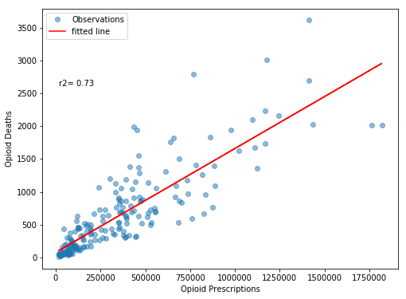

Figure 1 Trend analysis of Opioid prescription against opioid deaths

We took the same analysis further to check if the same pattern is true across the US states. Based the data collected we have found that many states e.g. Arizona, Indiana has shown even stronger r2 factor. At the same time some states have show no correlation at all. States like Connecticut, Washington, Utah has shown even less than 0.09 r2.

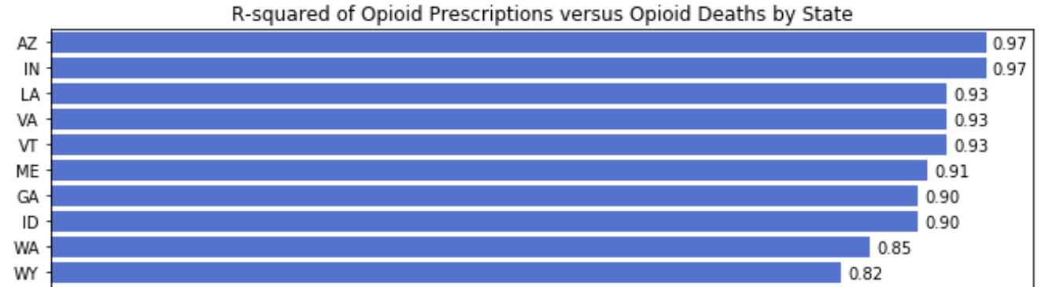

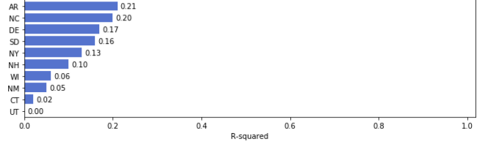

Figure 2 US States with maximum and minimum correlation

When we analyzed the overall drug overdose deaths with the opioid death, we found that the trend line shows a similar growth. A recent report from Center for Disease Control since 1990s the death from prescription opioids has increased with amount of opioid prescribed. From the same source it is stated that from 1999 to 2016 more than 200,000 people dies from prescribed opioid and during the same time, the amount of opioid prescribed has increased five times (CDC n.d.).

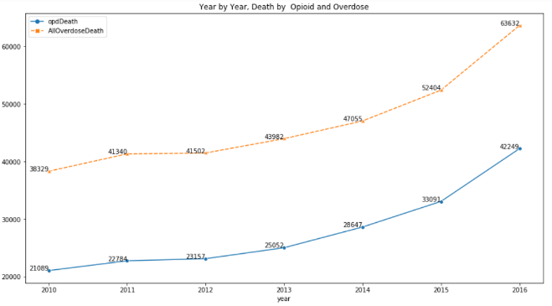

Figure 3 Trend analysis of Opioid overdose deaths with overall drug overdose death

**Initial Visualizations and Analysis**

The same dataset was analyzed further through different visualization techniques.

Here are few interesting findings. It was found that though the opioid overdose deaths have increased every year, the percentage change of this growth is not consistent. Even some years the growth rate has been lower than the change observed in the previous year.

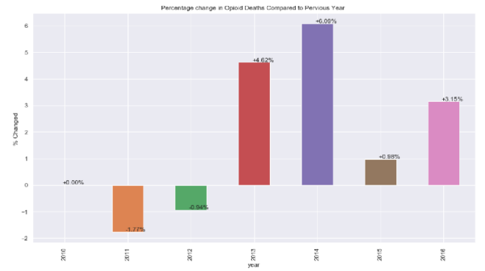

Figure 4 Opioid overdose death: Percentage change every year

The impact of the main class of drugs was visualized and was found that the drugs do tell their own story. The fatal overdoses from Heroin has been showing a consistent growth where are Methadone has been showing lower number over the same time period.

Fentanyl related deaths has been showing an alarming growth over recent years. The Drugs Enforcement Administration [NFLIS] has estimated that the drugs submission testing positive for Fentanyl has more than doubled in just one year in just 2015-2016. (CDC 2018)

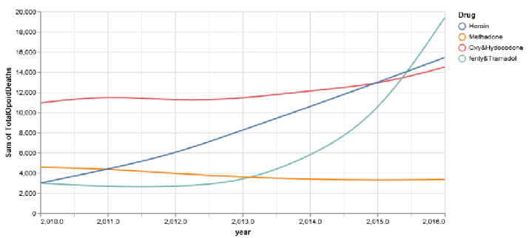

Figure 5 Opioid overdose death by drugs

**Analysis by States**

The national rate of opioid overdose death has increase significantly from 6% to 418% from 2010-2016. The sharp increase has seen several states located in the East, Midwest, and Appalachian regions of the country, including Ohio, New York, Pennsylvania, Illinois, Virginia and Florida. However, one western state California shows stable rate in opioid death.

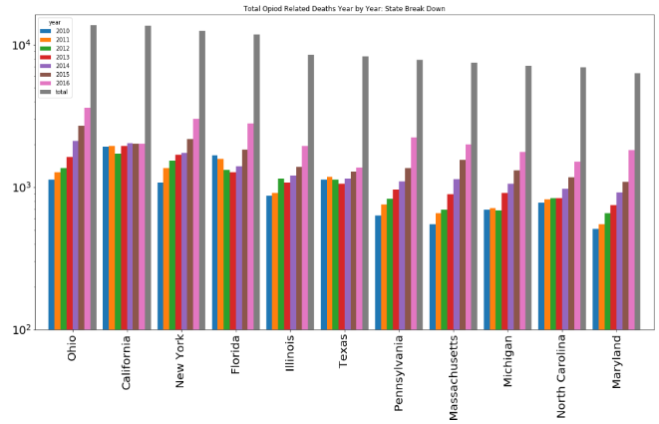

Figure 6 Opioid death in US states majorly

affected by the epidemic

Geospatial visualizations were very effective in analyzing the impact of the drugs across US states. It was found that while Oxycodone, Hydrocodone and Methadone has greater impact in California; the state of Ohio is showing higher impact from Fentanyl, Tramadol and Methadone.

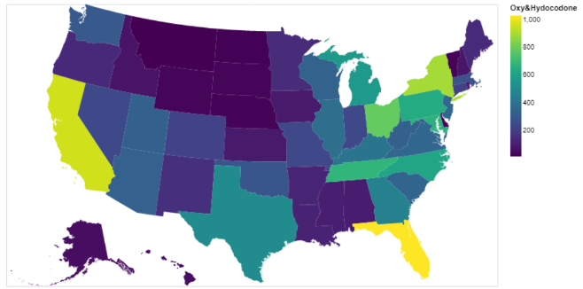

Figure 7 State-wise impact of Hydrocodone overdose deaths

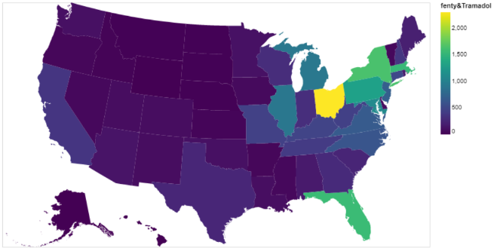

Figure 8 State-wise impact of Fentanyl overdose deaths

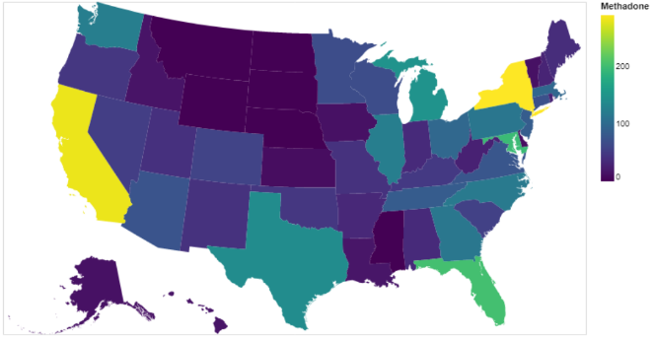

Figure 9 State-wise impact of Methadone overdose deaths

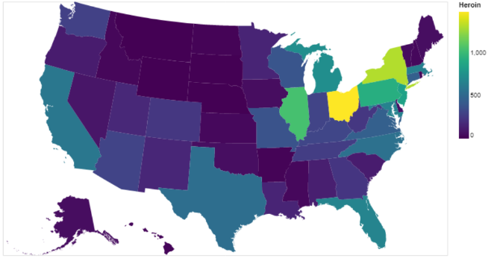

Figure 10 State-wise impact of Heroin overdose deaths

**Analysis by Gender**

This visualization analysis includes U.S. citizen who died from a drug overdose between 2010 to 2016. Overall, men are more likely than women to use the opioid drugs and is more likely to lead to overdose death. Of the decedents 127,080 were male and 68,916 were female.

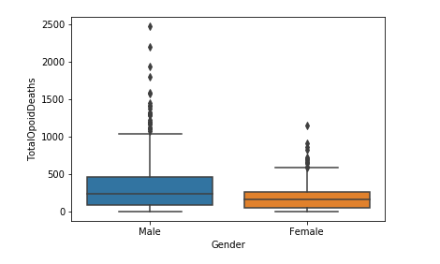

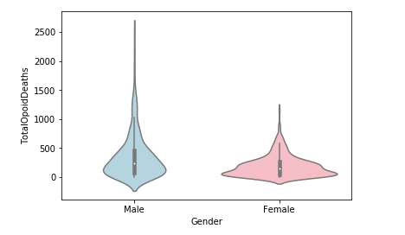

Figure 11 represents the number and data distribution of male and female died from opioid overdose. It is important to note that males disproportionately experienced opioid overdose deaths compared to females because males comprise about 49.2% percent of the U.S. population yet accounted for 64.8% percent of the opioid overdose deaths between 2010 to 2016. However, females comprise 50.8 percent of the population and accounted for 35.2 percent of the opioid overdose deaths reported in 2010 and 2016 period. Note: gender ratio statistical data from the United States Bureau shows that the female percentage in 2017 is 50.8%. (US Census n.d.)

**Analysis by Age**

From 2010 to 2016, most opioid overdose deaths occurred in people aged 25-44. The 25-44 age group represents the largest percentage of deaths, which is 24.3%. The second percentage of deaths is the 35-44, which is 21.9% (CDC 2018)

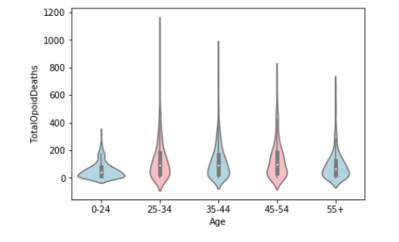

Figure 12 Opioid Overdose Deaths by Age Group

**Opioid Overdose Deaths by Race**

An article published by American Council of Science and Health in 2018, has shown that opioid overdose is a significant problem among whites than it in among others.

“When stratified by race/ethnicity, the drug-related mortality rate (per 100,000) in 2016 for whites was 25.3, blacks 17.1, and Hispanics 9.5. That means that whites were roughly 50% and 167% likelier to die from drug overdoses than blacks and Hispanics, respectively.” (Berezow 2018)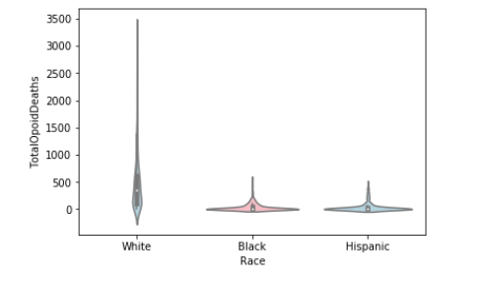

Figure 13 shows that from 2010 to 2016, 160,962 deaths were identified as White (84.6%), 12,588 were identified as Black (6.7 percent), 12,704 were identified as Hispanic (6.8 percent). The racial ratio for overdose deaths also matches with the racial demographics in the United States (US Census n.d.).

**Conclusion**

There have been several preventive measures taken to combat the epidemic. In 2015, the federal government launched an initiative to promote responsible opioid prescription. In 2016, CDC had set clinical standards to balance the benefit and risk of this class of drug. Apart from the regulations and standards in place, there has to be a combined effort from physicians, patients, and pharmacists to keep the problem in check. CDC has placed a guideline in their website. (NIH 2018)

In this analysis the amount of opioid prescribed mirrored the opioid overdose deaths. Apart from finding the correlation, the study analyzed several other dimensions of the dataset. It is important to understand the trend of this epidemic by gender, race, age and state so that appropriate preventive measures can be taken. There are states that has high availability of certain drugs while in some states certain age group shows a higher percentage growth than in other states. The socio-economic structure, demographic, and health care system might have varied impact on controlling the epidemic that has to be studied further.

Fentanyl is a highly addictive pain medication commonly used to treat pain in cancer patients undergoing chemotherapy. It can cause respiratory distress and death when combined with other substances especially alcohol.

For the growth of fentanyl related incidents, CDC reported that highest number of the drug submission concentered in the East and Midwest region on the country. Detailing further the affected population, stayed mostly on the east of the Missisippi river or in the area bordering the river. This geographic clustering can lead to a link to illicit fentanyl supply along with the drug Heroin. (CDC 2018) This kind of further analysis of such findings can help mitigate the issue from the root.

Prescription opioids were the leading cause of spoiling the habit of the population. To summarize the problem, it can be pointed to three sources to be targeted: surge of prescription opioids since 1990, increase of heroin related deaths from 2010, and the growing supply chain of illegally manufactured drugs including fentanyl.

# **Works Cited**

Amos, Owen. 2017. *Why opioids are such an American problem.* 25 Oct. https://www.bbc.com/news/world-us-canada-41701718.

Berezow, Alex. 2018. *White Overdose Deaths 50% Higher Than Blacks, 167% Higher Than Hispanics.* 5 Apr. https://www.acsh.org/news/2018/04/05/white-overdose-deaths-50-higher-blacks-167-higher-hispanics-12804.

CDC. n.d. *Prescription Opioid Data.* https://www.cdc.gov/drugoverdose/data/prescribing.html.

—. n.d. *Provisional Drug Overdose Death Counts.* https://www.cdc.gov/nchs/nvss/vsrr/drug-overdose-data.htm.

—. 2018. *Rising Numbers of Deaths Involving Fentanyl and Fentanyl Analogs.* 11 Jul. https://emergency.cdc.gov/han/HAN00413.asp.

—. 2018. *U.S. drug overdose deaths continue to rise; increase fueled by synthetic opioids.* 29 Mar. https://www.cdc.gov/media/releases/2018/p0329-drug-overdose-deaths.html.

Github. n.d. *github.com.* https://github.com/rashray/Opiod-Epidemic-Project/blob/master/data/Final_OpiodData2010_2016.csv.

GitHub. n.d. *State Drug Utilization Data.* https://raw.githubusercontent.com/rashray/Opiod-Epidemic-Project/master/data/State_Drug_Utilization_Data_2017-2013%20Opioids.csv.

Henry J Kaiser Foundation. n.d. *State Health Facts.* https://www.kff.org/state-category/health-status/opioids/.

National Institute on Drug Abuse. 2018. *Opioid Overdose Crisis.* March. https://www.drugabuse.gov/drugs-abuse/opioids/opioid-overdose-crisis.

NIH. 2018. *Misuse of Prescription Drugs.* Jan. https://www.drugabuse.gov/publications/research-reports/misuse-prescription-drugs/how-can-prescription-drug-misuse-be-prevented.

US Census. n.d. *QuickFacts.* https://www.census.gov/quickfacts/fact/table/US/PST045217.

—. n.d. *QuickFacts 2013-2017.* https://www.census.gov/quickfacts/fact/table/US/LFE046216.

Wikipedia. n.d. *Kaiser Family Foundation.* https://en.wikipedia.org/wiki/Kaiser_Family_Foundation#cite_note-aboutKFF-2.

—. n.d. *Opioid epidemic.* https://en.wikipedia.org/wiki/Opioid_epidemic.

Wickman, Hadley. 2014. Tidy Data, *Journal of Statistical Software*. volume 59, issue 10